**EXECUTION ORDER FORM**

To order development of RICEF based on: Project Requirement

Module: Material Management

Name of Functional Specification: Pipeline Alokasi

Code of Functional Specification: Copy from ZMMDT0340, ZMMDT0341, ZMM6138

Signed by:

|  |  |  |
| --- | --- | --- |
| Consultant | Business Owner | Abaper |
|  |  |  |
|  |  |  |
| Koen Dian Pancawati | Danar | Carito Sabar |
| KIT SAP MM Functional | KBI Procurement | KIT ABAPER |

## General status information.

|  |  |
| --- | --- |
| **Reference ID.** | Copy program from ZMM6138 |
| **Spec ID** | FSMM |
| **Priority** | Medium |
| **Version** | 1.0 |
| **Business Owner** |  |
| **Description** |  |
| **Prepared By** | Ahmad Naufal Primadhika M |
| **Estimated Development Time** |  |
| **Date of Creation** | 31/07/2023 |
| **Date (last modified)** |  |
| **Due Date** | 06.09.2023 |

|  |
| --- |
| ***Reason why not using the Standard SAP*** |
| ***Data yang dibutuhkan tidak tersedia pada SAP Standard*** |

Business Specifications and Requirements.

## Business Requirements Description

Pipeline Alokasi dibawa dari CRM ke KBI

## Business Requirements Specifications

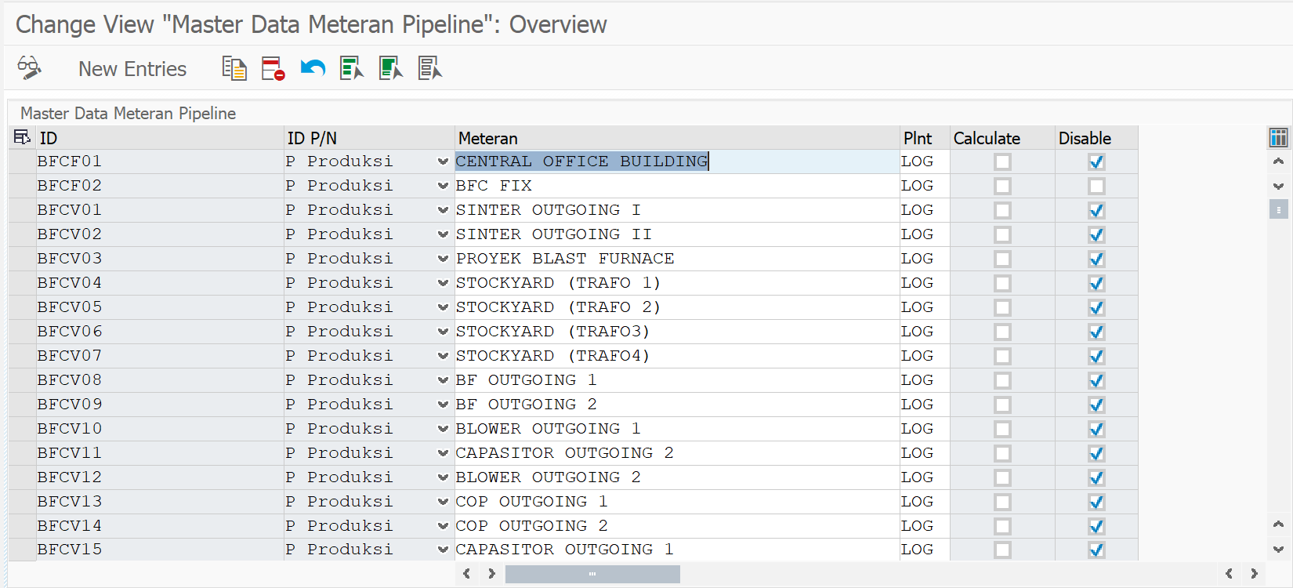

**Note:**

1. Plant

Get ZMMDT0341 – WERKS

IF (ZMMDT0341 – WERKS EQ KBI1)

Then New Entries and Change Master Data Meteran Pipeline

Else (ZMMDT0341 – WERKS NE KBI1)

Then Comments “You are not Authorized”

End IF

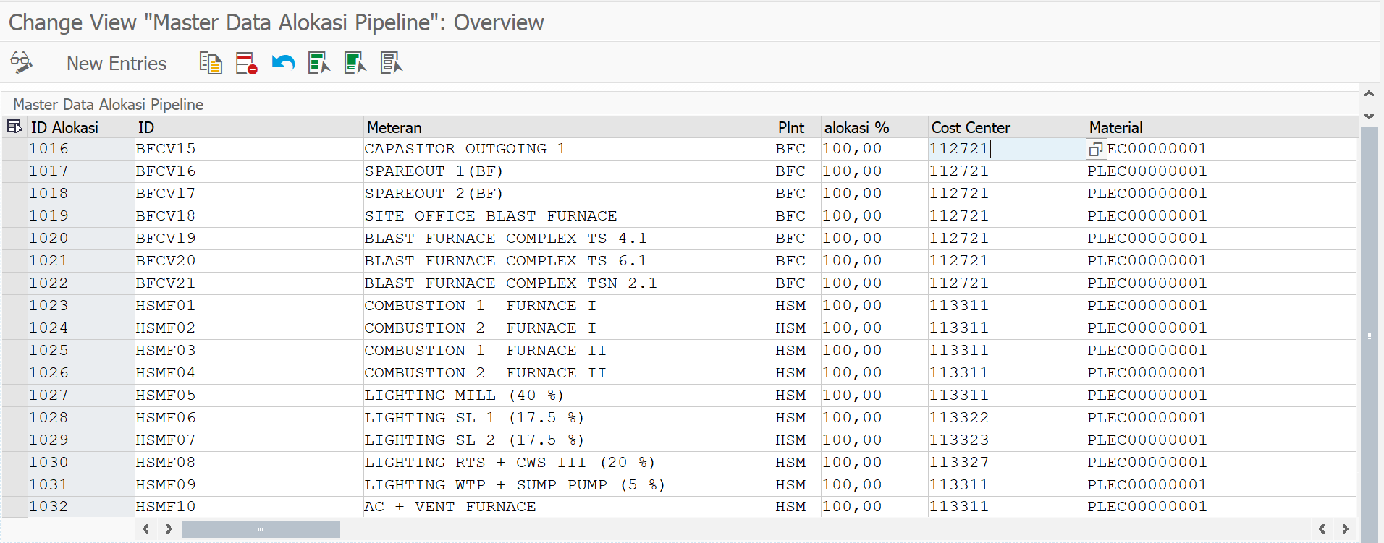

**Note:**

1. Plant

Get ZMMDT0340 – WERKS

IF (ZMMDT0340 – WERKS EQ KBI1)

Then New Entries and Change Master Data Alokasi Pipeline

Else (ZMMDT0341 – WERKS NE KBI1)

Then Comments “You are not Authorized”

End IF

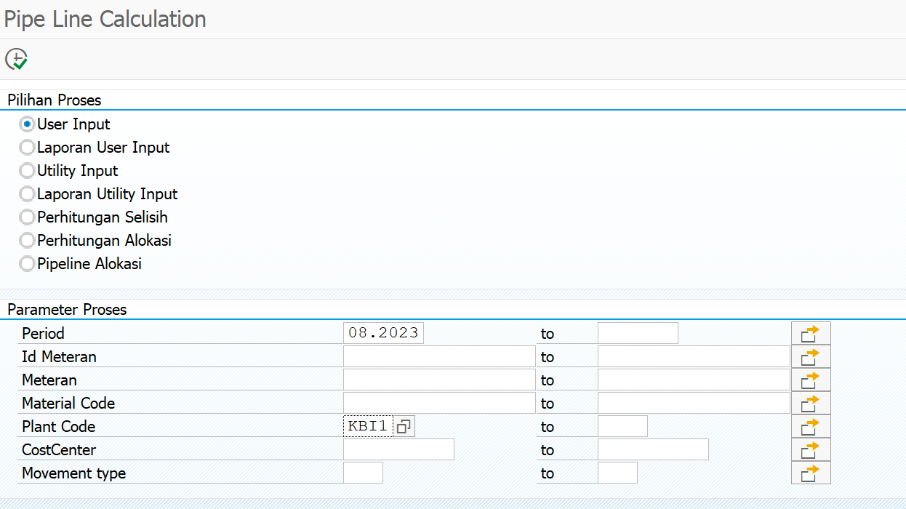

**Note:**

1. Plant Code (Dibuat Mandatory)

Get MSEG – WERKS

IF (MSEG – WERKS EQ KBI1)

Then Execute

ELSE (MSEG – WERKS NE KBI1)

Then “You are not authorized”

Utility Input:

Untuk utility dibuatkan table penampung baru dengan ZMMDT0347 yang di copy dari Table ZMMDT0343

Plant Code (Dibuat Mandatory)

Get MSEG – WERKS form Selection Screen

IF (MSEG – WERKS EQ KBI1)

Then Execute

And Display/Change only Plant KBI1(Di kelompokan seperti HSM dan CRM)

And Meteran selain KBI1 tidak ditampilkan

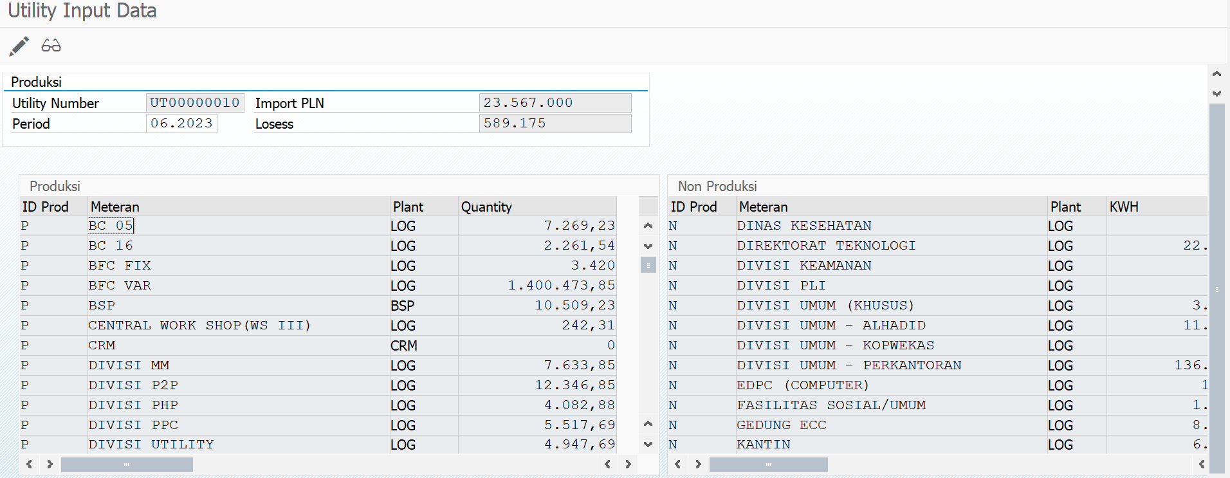

Else IF (MSEG – WERKS NE KBI1)

Then Execute

And Read Table ZMMDT0343

End IF

Untuk Perhitungan Selisih:

Plant Code (Dibuat Mandatory)

Get MSEG – WERKS from Selection Screen

IF (MSEG – WERKS EQ KBI1)

Then Execute

And Run Note

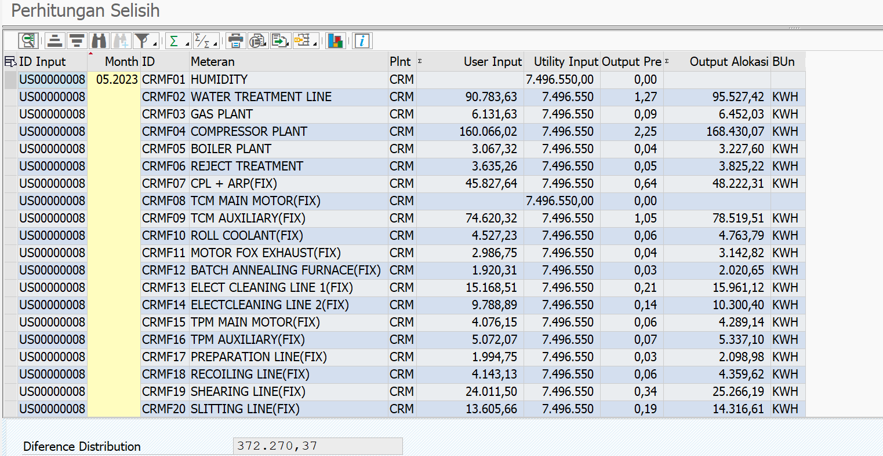

**Note:**

1. Utility Input:

Get ZMMDT0347 – ZKWH

Where ZMMDT0347 – WERKS = KBI1

Else (MSEG – WERKS EQ KBI1)

Then Execute

And Run Exisiting Program

Untuk Perhitungan Selisih:

Plant Code (Dibuat Mandatory)

Get MSEG – WERKS from Selection Screen

IF (MSEG – WERKS EQ KBI1)

Then Execute

And Run Note

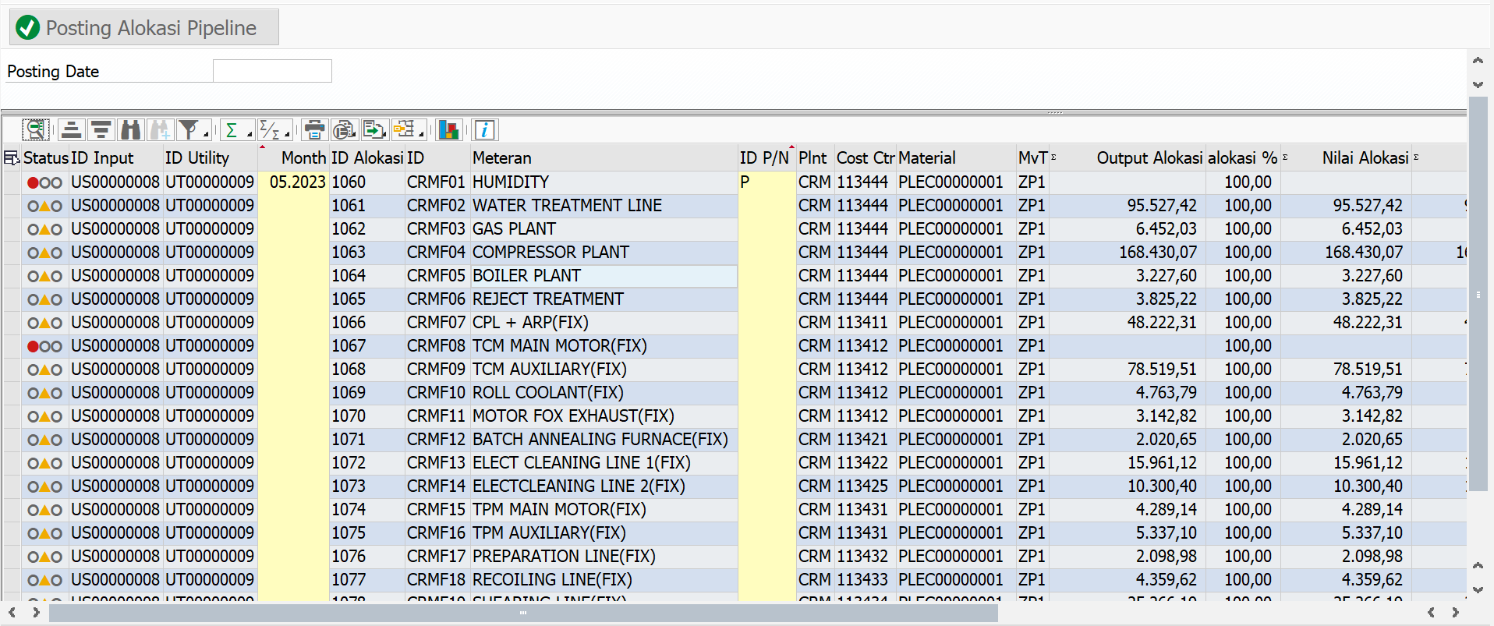

Note:

1. Output Alokasi diambil dari perhitungan selisih program baru ketika kondisi Plant CRM

Else (MSEG – WERKS EQ KBI1)

Then Execute

And Run Exisiting Program